
Tertiary Infotech Academy Pte Ltd
UEN: 201200696W
ANSWER TO PRACTICAL PERFORMANCE ASSESSMENT
For
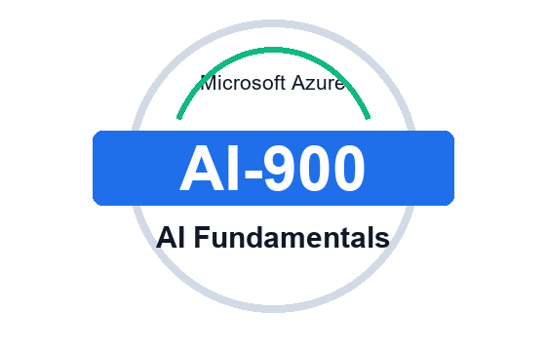
Microsoft Azure AI Fundamentals (AI-900)
TGS Ref No: TGS-2023021100
Conducted by
Tertiary Infotech Academy Pte Ltd
UEN: 201200696W
Version v1

Answer Guide - Practical Performance Assessment
Microsoft Azure AI Fundamentals (AI-900) - TGS-2023021100 - v1

Scenario
A retail and service organisation wants to introduce Azure AI capabilities across customer support, document processing, product quality review, multilingual communication, analytics and internal knowledge workflows. Complete the practical tasks below by following the sequence and evidence produced in the AI-900 labs.

Marking Guidance
- Award competence when the learner provides valid lab-aligned evidence and can explain the service choice.
- PP evidence may include screenshots, completed tables, validation notes, control checklists and cleanup notes.
- The assessor should check the practical evidence against the listed lab sources.

Task 1 (LO1) - Labs 01 and 10
Classify AI workloads, map them to Azure AI services and create a responsible AI checklist for the organisation's scenario.
Expected practical evidence / model performance points:
- From Lab 01, list at least five business scenarios and classify each AI workload.
- Map each workload to the closest Azure service: Vision, Language, Speech, Document Intelligence, Azure Machine Learning, Azure AI Foundry or Azure OpenAI.
- Create a responsible AI checklist covering fairness, reliability, privacy/security, inclusiveness, transparency and accountability.
- From Lab 10, refine the service map into a final scenario-service-control recommendation.

Task 2 (LO2) - Labs 02 and 03
Prepare a machine learning solution outline that identifies the ML technique, features, labels, lifecycle stages and Azure Machine Learning evidence.
Expected practical evidence / model performance points:
- From Lab 02, distinguish regression, classification and clustering for the given business examples.
- Identify possible features, labels and evaluation measures.
- From Lab 03, describe the Azure Machine Learning or AutoML lifecycle: prepare data, train, evaluate, deploy and monitor.
- State what evidence validates the model or workspace activity.

Task 3 (LO3) - Labs 04, 05, 06 and 07
Complete an Azure AI services evidence pack for vision, language, speech/translation and document intelligence or search.
Expected practical evidence / model performance points:
- From Lab 04, validate image analysis, OCR or object detection output and note any accuracy/privacy issue.
- From Lab 05, validate language outputs such as sentiment, key phrases or entities.
- From Lab 06, validate speech recognition, synthesis, translation or conversational AI output.
- From Lab 07, validate document extraction or knowledge mining/search evidence.
- For each service, state the input, output, Azure service used and human review point.

Task 4 (LO4) - Lab 08
Use generative AI concepts to design a safe Azure AI Foundry or Azure OpenAI interaction for a business support scenario.
Expected practical evidence / model performance points:
- From Lab 08, define the user task and draft a clear prompt or system instruction.
- Identify whether the answer needs grounding or retrieved context.
- Name the relevant Azure AI Foundry, Azure OpenAI or model catalog concept used in class.
- Describe content safety, evaluation and human review controls.
- Record the final response quality check and any limitation.

Task 5 (LO5) - Labs 09 and 10
Produce a final Azure AI solution design that includes service selection, governance, security, cost controls, validation and cleanup.
Expected practical evidence / model performance points:
- From Lab 09, document requirements, selected service, data boundary, RBAC/access, privacy/security controls and cost considerations.
- Add monitoring, budget alert or free-tier considerations where applicable.
- From Lab 10, complete the capstone service map and course review evidence.
- State how learners validate the output and what resources must be deleted or stopped.
- Confirm the design aligns to the final service selection checklist from the slides.

